Ramzi Haddad

Comp3064_Assingment1

Contents

Description 2

Controls Description 2

Interface sketch 3

Screen Descriptions 5

Enemies 8

Scoring 8

Sound Index 8

Art /Multimedia 8

# Description

2D Shooter is an action game made by Ramzi Haddad. this game is made to meet the assignment 1 requirements. This game consists of three main Characters. The first Character is the player. The player mission is to shoot the enemy tanks in order to stop them from hitting the wall. The wall consists of 3 pieces that reduce the Player health points by 5 point each time an enemy tank collides with one of the pieces. The enemy tanks are made to move to the wall horizontally and it generate from different places on the screen. the game uses a background that is made in way that shows the ground as a flat land so objects like tanks will look like they are going on a ground not in the air. The background photo is taken with an angel that makes look flat. The main tank will shoot bullets that will collide with the enemy tanks and destroy the enemy tanks. Also when the player tank collides with enemy tank the health of the player will reduce by 10 points (But the enemy tank will stay on the same place until it gets hit by either a bullet or a wall). The enemy level will increase each 30 points the player earns . first the enemy tank’ s speed will increase for the first 75 points . then two or 3 tanks will appear on the screen .Then their speed will increase . Finally another tank will appear and the speed of the tanks will increase.

# Controls Description

The are four controls in the game . the first is script that is responsible to move the background according to the player movement . if the player moves up the background will move up as well . The Second control is the player controller which is simply the standard controls . when the player click the w or the up button the player will move up and so for the other directions based on the standard wasd controls.

The third control the enemy control that generates enemy based on the algorithm that I have explained in the Description. It will generate enemy that moves from different vertical places on the screen toward the wall. As well as it control the number of enemies to generate.

The last control is the health and the points counter that decides when to stop the game and when to restart the status.

# Interface sketch

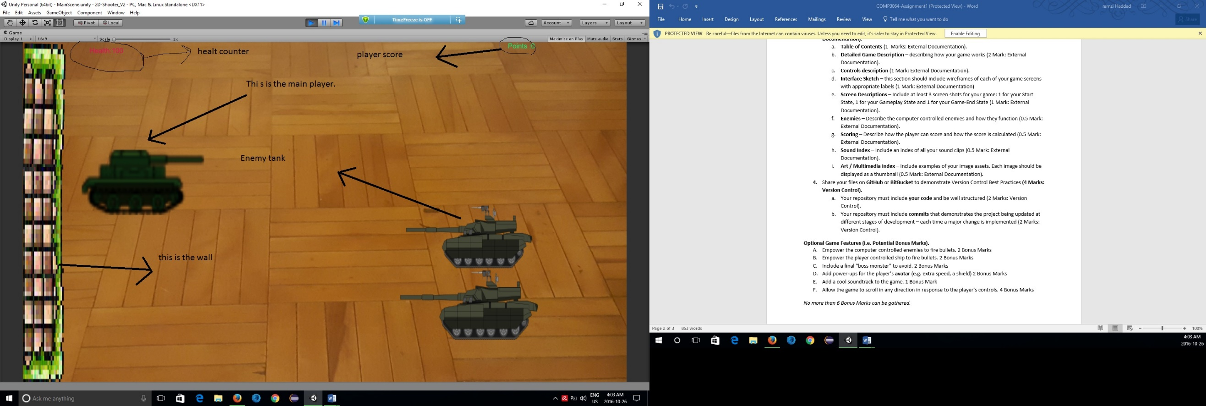

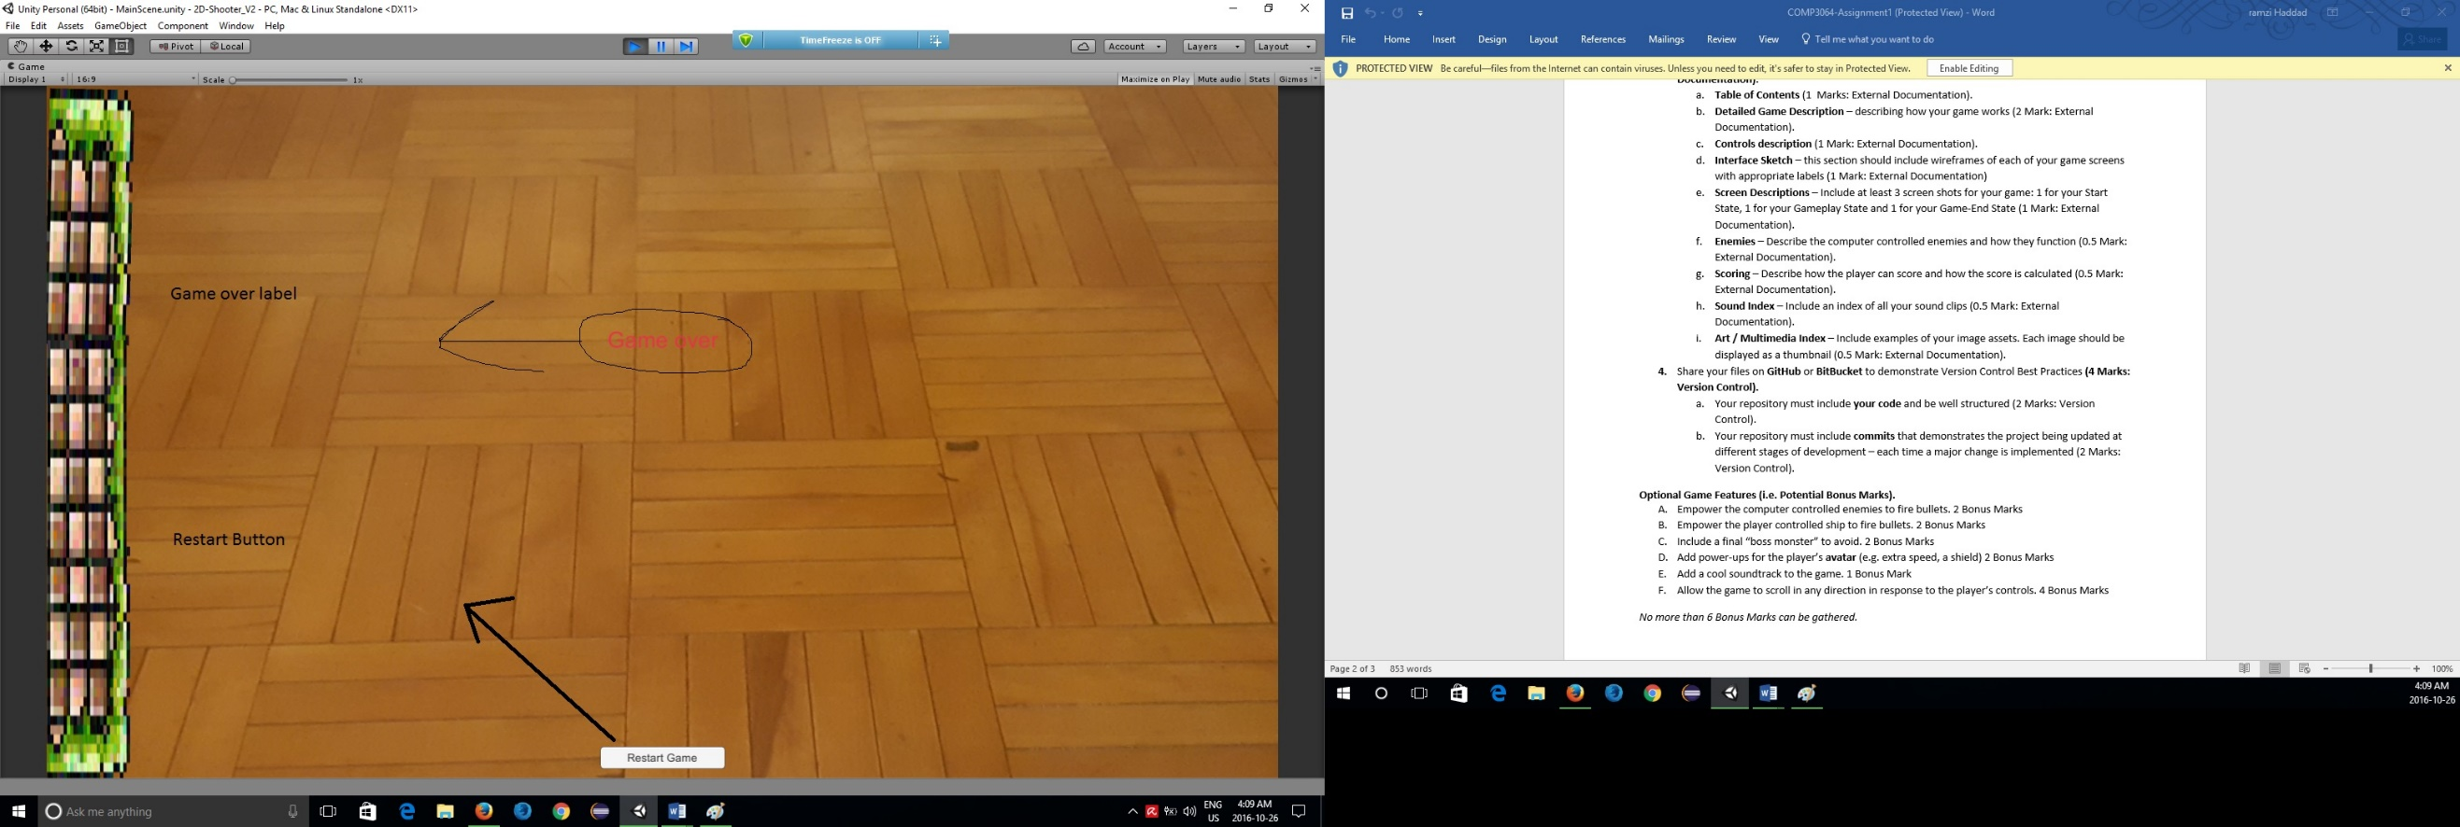

# Screen Descriptions

First start

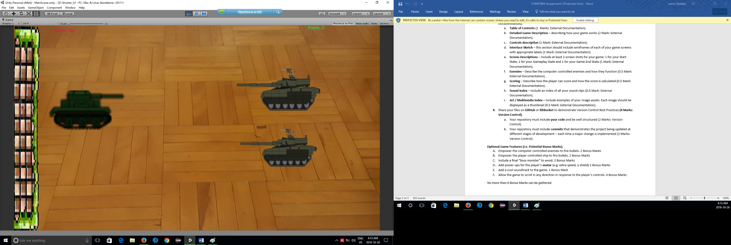

In game

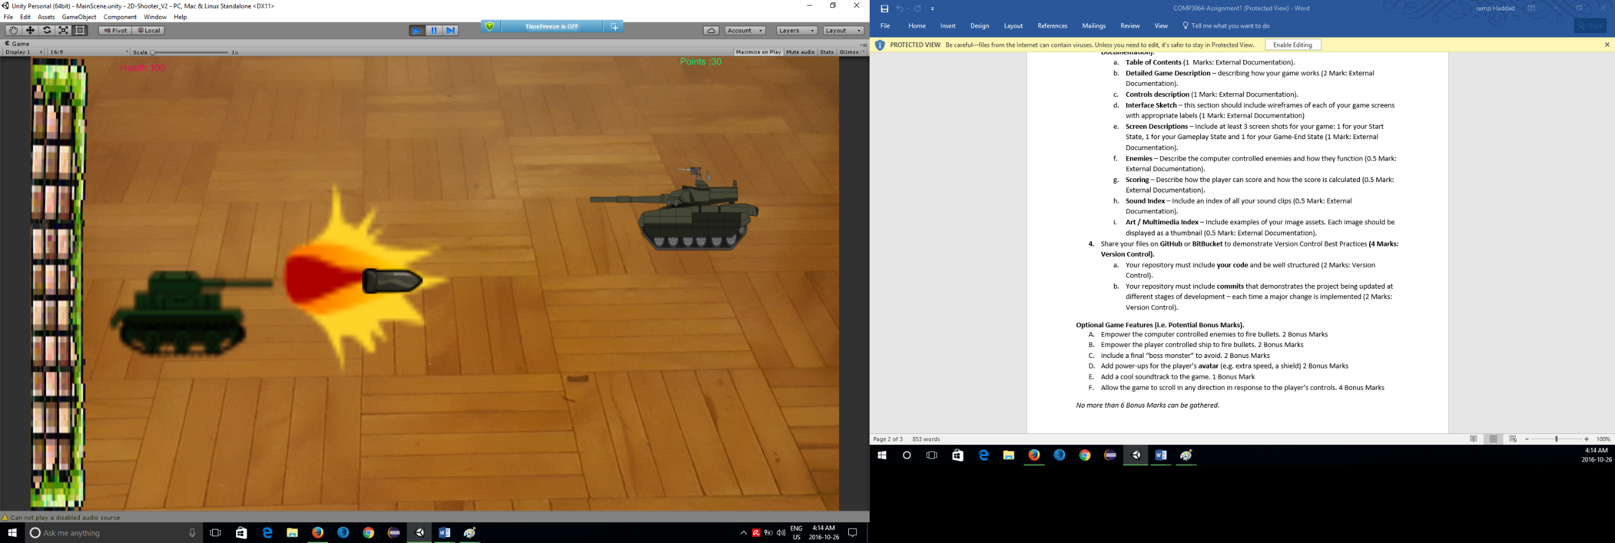

Game Over

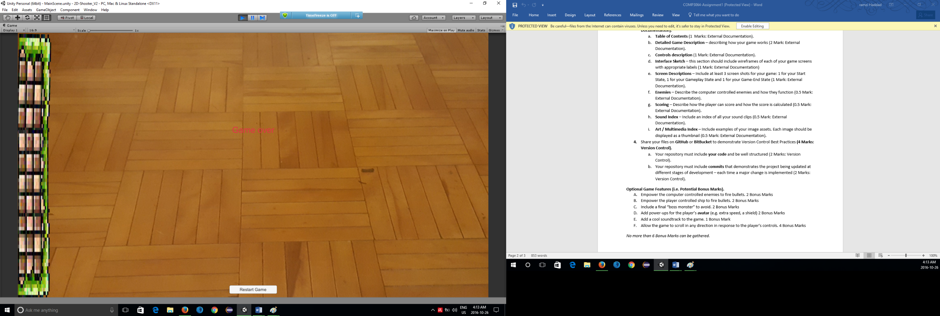

# Enemies

The enemies consist of multiple moves in different speed based on the player. It starts with 2 tanks that moves very slow . Then when the score goes over 30 the enemy tanks will pick up more speed . if the player scored over 60 the speed of the tanks will double . Also when the score goes over 100 the tanks will be fast . The number of tanks will increase when the score goes over 75 another tank will appear . When the scores goes over 200 there will be three or four tanks on the screen .

# Scoring

The score will increase when the player successfully shoot an enemy tank .

# Sound Index

Background audio.mp3

Bulletsound.mp3

Tankexplosion.mp3

# Art /Multimedia

